PROJECT PROPOSAL

Email Spam Detector: Chrome Extension with Python Backend

Team Members
Team Lead: Anchal Anchal (300364004)
Team Member: Gunleen Kaur (300373306)
Course
Course Name: 4495 – Applied Research Project
Section: 002

Introduction
Email spam has become a pervasive issue in digital communication, impacting users worldwide by cluttering inboxes, reducing productivity, and exposing individuals and organizations to significant cybersecurity risks. Spam emails are often carriers of phishing links, scams, and malware, targeting unsuspecting recipients to compromise their personal and financial information. Despite the availability of various spam detection systems, spammers continually evolve their techniques to bypass traditional filters, leading to a persistent need for more advanced and accessible solutions.
To address this challenge, the proposed project seeks to develop a lightweight, efficient, and user-friendly Chrome extension for detecting spam emails. By leveraging Python's robust text processing capabilities, the project will deliver a seamless and real-time solution that integrates directly with popular email platforms, such as Email. This innovative tool will prioritize simplicity, accuracy, and accessibility, ensuring that even non-technical users can enhance their email security effortlessly.

Background
The rise in email communication has been paralleled by the exponential growth of spam emails, which now constitute nearly half of global email traffic. These unwanted emails are not only a nuisance but also a significant threat to personal and organizational security. Spam emails often include malicious attachments, phishing links, or fraudulent schemes designed to deceive recipients into sharing sensitive information or making payments.
Traditional spam detection mechanisms, such as keyword-based filters and heuristic algorithms, provide a basic level of protection. However, they often fall short in addressing the contextual and evolving nature of spam content. For instance, a keyword filter may block legitimate emails containing flagged terms, leading to false positives, or miss sophisticated spam emails that avoid obvious triggers. Advanced server-side solutions, such as Bayesian classifiers and machine learning models, offer improved accuracy but are typically resource-intensive, requiring complex setup and server infrastructure.
In this context, lightweight browser-based tools that integrate directly with email clients represent a promising alternative. Such solutions can provide real-time spam detection with minimal user intervention, reducing the reliance on external services and improving the end-user experience. This project seeks to fill the gap by designing a Chrome extension powered by Python to deliver efficient spam detection directly within the user's browser.

Problem Statement
Despite the availability of advanced spam detection systems, many solutions are either resource-heavy, requiring server-side infrastructure, or overly simplistic, relying on basic keyword filtering. These systems often fail to adapt to the rapidly evolving tactics of spammers or to provide a seamless, user-friendly experience for non-technical users.
The challenge lies in developing a lightweight, browser-based tool that integrates effectively with email platforms like Gmail, processes email content in real time, and delivers accurate spam detection results. Such a solution should strike a balance between simplicity, efficiency, and adaptability while leveraging Python's powerful text analysis capabilities.

Research Goals
This project is guided by the following objectives:
- Development of a Chrome Extension: Create an intuitive and user-friendly browser extension that integrates seamlessly with email clients.
- Python-Based Backend: Implement a Python backend to process email data and detect spam using techniques like keyword analysis, with future provisions for machine learning.
- Real-Time Detection: Ensure that the system provides instant results with high accuracy, distinguishing spam from legitimate emails effectively.

Literature Review
Existing Spam Detection Methods:
- Keyword Filtering: Identifies spam based on specific words or phrases commonly used in spam emails. While simple and fast, it often generates false positives and misses subtle spam content.
- Heuristic Algorithms: Use rule-based systems to classify emails as spam or non-spam. These algorithms are limited by their reliance on predefined rules, which spammers can bypass.
- Bayesian Classifiers: Employ probabilistic models to determine the likelihood of an email being spam based on its content. These models are more flexible but require training and maintenance.
- Machine Learning Models: Utilize advanced algorithms, such as Support Vector Machines (SVMs) or neural networks, to analyze patterns in email content. While highly accurate, these models demand substantial computational resources and complex infrastructure.

Identified Gaps:
- Many existing solutions are server-based, making them less accessible to individual users.
- Lightweight, browser-integrated spam detection tools with real-time capabilities are limited in availability.
- Existing tools often lack user-friendly interfaces, posing a challenge for non-technical users.
This project seeks to address these gaps by combining the simplicity of a browser extension with the processing power of Python for efficient and accurate spam detection.

Hypothesis and Benefits
The project hypothesizes that a Python-powered Chrome extension, integrated directly with email clients, can provide an accessible, real-time spam detection solution. This approach reduces dependency on external services and provides users with a lightweight, intuitive tool for enhancing their email security.
Key Benefits:
- Accessibility: A browser extension eliminates the need for server-side setups, making the solution more accessible to everyday users.
- Real-Time Results: Direct integration with email platforms ensures instant detection and classification of spam.
- User-Friendliness: The simple interface caters to non-technical users, enabling effortless spam detection without complex configurations.

Proposed Research Project
Objectives
- Design a Chrome extension that integrates seamlessly with email to extract and analyze email content.
- Implement a Python backend using Flask to process email data and execute spam detection logic.
- Deliver a lightweight, real-time spam detection tool that ensures high accuracy and ease of use.

Methodology
Research Design:
- Develop the Chrome extension frontend using HTML, CSS, and JavaScript.
- Use Chrome's content scripts to integrate with email and extract email content.
- Implement a Flask-based backend in Python for processing email data.
- Begin with keyword-based spam detection and design provisions for machine learning upgrades in future iterations.
Data Collection:
- Utilize publicly available spam email datasets, such as the Enron email dataset, for training and validation.
- Collect sample emails from your accounts (with user consent) to refine detection logic.

Technology Stack:
- Operating System: Windows/Linux.
- Programming Language: Python.
- Database: MySQL.
- Frontend: HTML, CSS, JavaScript.
- Backend Framework: Flask.
- Machine Learning Libraries: scikit-learn.
- Other Tools: Git for version control.

Expected Results
- Development of a fully functional Chrome extension that integrates with email for real-time spam detection.
- High accuracy rates in identifying spam emails, distinguishing them from legitimate content effectively.
- Contribution to the development of lightweight, user-friendly tools for enhancing email security, benefiting both technical and non-technical users.

Project Planning and Timeline
Responsibilities
- Anchal Anchal (Team Lead): Coordinate tasks, develop backend (Flask), integrate with frontend.
- Gunleen Kaur: Design and develop Chrome extension UI, test and document features.

Timeline:
Phase | Task | Duration
Phase 1 | Requirement Analysis | 1 week
Phase 2 | Dataset Collection & Preprocessing | 2 weeks
Phase 3 | Model Training & Evaluation | 3 weeks
Phase 4 | Web GUI Development | 3 weeks
Phase 5 | Testing & debugging | 2 weeks
Phase 6 | Documentation & Deployment | 1 week

Project Management
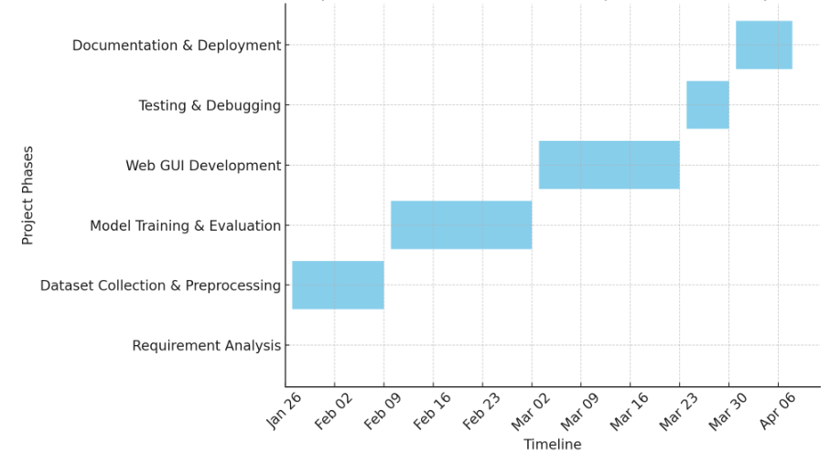

Project Contract
We, the undersigned, agree to the scope and timeline outlined in this proposal. We commit to fulfilling our responsibilities and collaborating effectively.
Anchal Anchal
Gunleen Kaur

Work Date/Hours Logs
Student Name | Date | Hours Worked | Description
Anchal Anchal | Jan 14, 2025 | 2 | Initial research on spam detection
Gunleen Kaur | Jan 16, 2025 | 1.5 | Search on tools and components
Both Members | Jan 20, 2025 | 3 | Started working on the project
Gunleen Kaur | Jan 22,2025 | 0.5 | Creating Repository and adding files and folders
Anchal Anchal | Jan 24, 2025 | 1.5 | Started working on frontend of the project.
Gunleen Kaur | Jan 25,2025 | 1.5 | Finalising and editing of proposal.

Conclusion
This project aims to address the persistent issue of spam emails by developing a lightweight, Python-powered Chrome extension integrated with mail. By combining real-time email analysis with an intuitive interface, it offers a user-friendly solution for spam detection. Starting with keyword-based detection and laying the groundwork for machine learning enhancements, the project prioritizes accessibility, accuracy, and scalability.
The anticipated outcomes include not only reducing the intrusion of spam but also minimizing risks associated with phishing and malware. This solution demonstrates a significant step toward enhancing email security for everyday users while paving the way for future innovations in browser-based spam detection technologies.

Closing and References
Acknowledgment
We thank our course instructor for guidance and support throughout this project. We also appreciate the availability of open-source tools and documentation that made this project feasible.
References
- Python Flask Documentation: https://flask.palletsprojects.com/
- Chrome Extension Developer Guide: https://developer.chrome.com/docs/extensions/
- Open-source spam datasets: https://kaggle.com/

